Exercises – Survival analyses

In this exercise, we will use data from a cohort-study to analyse the association between smoking and risk of coronary heart disease (CHD). Risk factor data on 1979 participants in a health survey (age 50-93 at baseline) who were free of CHD at the time of participation were linked to registry-data on deaths and hospitalizations to obtain information on CHD-diagnoses during up to 20 years of follow-up. Participants were examined between 1995 and 2001 and followed until December 31th 2014.
The event of interest is incident CHD defined as a hospitalization with CHD (ICD9-codes 410-414, ICD10-codes I20-I25) as primary or secondary diagnosis or a death without hospitalisation with CHD as the underlying cause.
Information on risk factors, deaths and hospitalisations are stored in three separate datasets. We are going to merge the different datasets and define variables for the endpoint and follow-up time.
Then we will make Kaplan-Meier curves and perform Cox regression and competing risk regression to investigate the association between smoking and CHD.
An overview of the variables are listed in the tables below:
Table 1: Surveydata.dta
Variable | Explanation
partid | Participation ID
sex | Sex (0=woman, 1=man)
age | Age at baseline
sbp | Systolic blood pressure
chol | Total cholesterol
hdl | HDL cholesterol
smoke | Smoking (0=non-smoker, 1=smoker)
exdate | Examination date in health survey

Table 2: Hospitalizations.dta
Variable | Explanation
partid | Participation ID
hosp_date | Date of hospitalization
dia1 | Primary diagnosis (ICD9 or ICD10-code)
dia2-dia10 | Secondary diagnoses (ICD9 or ICD10-code)

Table 3: Deaths.dta
Variable | Explanation
partid | Participation ID
death_cause | Underlying cause of death (ICD9 or ICD10-code)
death_date | Date of death

Exercise 1: Merge files and make endpoints

- Start Stata and open the do-file exercises_survival.do. Code for all the exercises are given in this file. To run code: Highlight the command and press on the task bar. In order to make the code work you have to change the file path for the cd-command to the folder were you have stored the datasets.
Then you have to run the cd-command to change the working directory to the correct folder.
- Open the dataset with the baseline survey-data by running the following command from the do-file:
use surveydata, clear
Run the describe and codebook-commands to get an overview of the data. How many smokers are there in the dataset?
- You can also get a description of the dataset with deaths without opening the dataset with the following command:
describe using deaths
The dataset with deaths has 838 observations which means that 838 out of 1979 participants died during follow-up.
- Open the dataset with hospitalisations and get a description of the data by running the following commands from your do-file:
use hospitalizations, clear
describe
codebook partid
There are 7216 observations and 1381 unique values for the variable partid, which means that there are multiple hospitalizations for the same person. In addition there are hospitalizations for a wide range of different diagnoses, and we are only interested in the first hospitalization with CDH after the participation-date in the health survey.
- Run the following code to generate the variable chd_hosp which identifies CHD-hospitalizations and delete rows not containing CHD-diagnoses:
gen chd_hosp=0
foreach var of varlist dia* {
replace chd_hosp=1 if inlist(substr(`var',1,3), /// "410","411","412","413","414") ///
| inlist(substr(`var',1,3), "I20","I21","I22","I23","I24","I25")
}
tab chd_hosp
keep if chd_hosp==1
- There are still multiple rows per person (because some persons have more than one CHD-hospitalisation) and we only want to keep the first one after participation. Run the following code to merge the variable for examination date with the hospitalization-data:
merge m:1 partid using surveydata, keepusing(exdate) nogenerate
The date of examination has now been added to all rows in the dataset. If you look at the data you will see that for all hospitalizations the date of hospitalization is after the examination date, which means that none of the participants have had any CHD-hospitalizations prior to the participation date. This will not always be the case when you link different registries. If a person has already had the endpoint before baseline you should exclude the person from the analyses. In our case this is not a problem and we can use the minimum hospitalization date as the endpoint-date.
- Run the following code to obtain a variable containing the minimum date of CHD-hospitalization for each person:
bysort partid: egen chd_hosp_date=min(hosp_date)
format chd_hosp_date %td

- Run the following code to keep only necessary variables and only the first hospitalization for each person:
keep partid chd_hosp chd_hosp_date
duplicates drop partid chd_hosp chd_hosp_date, force
codebook partid
save chd_hosp, replace
The dataset chd_hosp.dta now contains only three variables: partid, chd_hosp and chd_hosp_date. The number of rows is 491 and all rows have a unique value for partid. The dataset is now ready to be merged with the surveydata, but we also need to merge information on deaths with the surveydata.
- Open the dataset surveydata again and merge with information on date and cause of death:
use surveydata, clear
merge 1:1 partid using deaths, keep(1 3) nogenerate
codebook death_date
Date of death varies between February 1996 and December 2014 and there are 1141 persons who do not have a date of death. These are the participants who are still alive at end of follow-up.

- Use the following code to generate event-variables for all-cause death (called death) and CHD-death:
gen death=!missing(death_date)
gen chd_death=inlist(substr(death_cause,1,3),"410","411", ///
"412","413","414") ///
| inlist(substr(death_cause,1,3),"I20","I21","I22","I23","I24","I25")
The variables are coded with 1 for events and 0 for those without the event. If you do a frequency count for the variables death and chd_death you will see that there are 838 deaths in total of which 147 have CHD as the underlying cause.
- In order to analyse risk of death we need a variable with time to death for those who dies and time to end of follow-up for those who are still alive at end of follow-up (censored individuals):
gen days_death=death_date-exdate
replace days_death=td(31dec2014)-exdate if death_date==.
tabstat days_death, by(death) s(n min max)
The results from the tabstat-command show that days until death varies from 12 days to 6981 among those who die during follow-up.
The dataset is now ready to be used in analyses of all-cause death and CHD-death, but we also want an endpoint were CHD-hospitalizations have been taken into account.
- Continue to add CHD-hospitalization with the following command:
merge 1:1 partid using chd_hosp, keep(1 3) nogenerate
replace chd_hosp=0 if chd_hosp==.

- Make a combined endpoint-variable for CHD which has the value 1 if a person has a hospitalization with CHD or a death from CHD and 0 otherwise:
gen chd_hospdeath=chd_hosp|chd_death
tab chd_hospdeath
There are in total 544 CHD-events during follow-up.
- Generate a variable with time to event or censoring with the following code:
gen days_chd_hospdeath=min(death_date, chd_hosp_date)-exdate ///
if chd_hospdeath==1
replace days_chd_hospdeath=death_date-exdate if /// chd_hospdeath==0 & death==1
replace days_chd_hospdeath=td(31dec2014)-exdate if chd_hospdeath==0 & death==0
We have two different groups of censored individuals: Those who die from other causes during follow-up and those who are still alive and free of CHD at end of follow-up

- Look at the distribution for the time-to-event variable and save the dataset:
codebook days_chd_hospdeath
save surveydata_endpoints, replace
There are no missing values or negative follow-up times, so everything looks ok. We are now finally ready to do some real analyses!

Exercise 2: Kaplan Meier survival curves
- We are going to make a Kaplan-Meier curve for time to CHD-hospitalisation or CHD-death, but first we have to tell Stata which variables to use for time-to-event and to separate between those who get the event and those who are censored. We use the stset-command for this and tells Stata to use the variables days_chd_hospdeath and chd_hospdeath with the value 1 for events and 0 for censoring:
stset days_chd_hospdeath, failure(chd_hospdeath==1) scale(365.25) id(partid)
The scale-option tells Stata to mesure time in years instead of days. Take a look in the output-window and in the data-browser to see the variables Stata has generated. The variable t0 tells you at which time-point the persons come under observation/ “at risk”. This is set to 0 (date of examination) for all pariticipants. The variable _t contains the timepoint for end of follow-up (either event or censoring). The variable _d is an indicator for event versus censoring.
- Estimate a Kaplan-Meier curve stratified on smoking-status with the following command:
sts graph, by(smoke)
The graph can be improved if you add some extra options:
sts graph, by(smoke) xtitle("Years from participation") ytitle("S(t)") ///
legend(order(1 "Non-smokers" 2 "Smokers"))
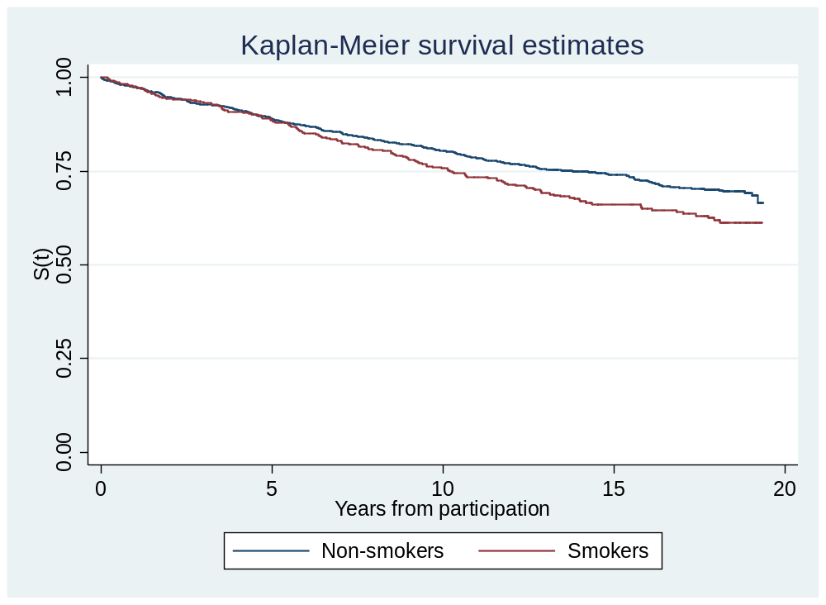
It looks like there is a difference in survival between smokers and non-smokers.
- You can test if the difference is significant with a log-rank test:
sts test smoke
Log-rank test for equality of survivor functions

| Events Events
smoke | observed expected
------------+-------------------------
Non-smokers | 397 423.06
Smokers | 147 120.94
------------+-------------------------
Total | 544 544.00

chi2(1) = 7.23
Pr>chi2 = 0.0072
From the output we see that p<0.05 and we conclude that there is a difference in risk of CHD between smokers and non-smokers. But we have not taken age into account. If there is a difference in age between smokers and non-smokers we could have a problem with confoundning.
- We can correct for age by using age as the time-scale. We already have the age at baseline, but we need a variable for age at end of follow-up. This can easily be obtained by adding the follow-up time to age at baseline:
gen age_chd=((age*365.25)+days_chd-hospdeath)/365.25
Run the stset-command again with age as the time-scale:
stset age_chd, failure(chd_hospdeath==1) enter(age) origin(time 0)
Time 0 when we use age as the time-scale is time of birth, but in this cohort the participants do not come under observation before the age when they participated in the health survey. We therefore have to use the enter-option to tell Stata when the participants come under observation. We have left-truncated data/delayed entry.
Take a look at the variables _t and _t0 for the first 10 observations in the dataset to see how the enter-option works:
list age _t0 _t _d in 1/10
. list age _t0 _t _d in 1/10

+------------------------------+
| age _t0 _t _d |
|------------------------------|
1. | 67.6 67.6 85.976456 0 |
2. | 59.1 59.1 77.002808 0 |
3. | 76.6 76.6 89.952499 0 |
4. | 73.6 73.6 75.083916 1 |
5. | 69.9 69.9 86.368172 0 |
|------------------------------|
6. | 68.2 68.2 85.944008 0 |
7. | 71.6 71.6 74.600685 1 |
8. | 60.9 60.9 74.871254 0 |
9. | 77.5 77.5 91.350784 0 |
10. | 73.8 73.8 79.491989 1 |
+------------------------------+

- Make a new Kaplan-Meier graph and compare with the graph we got when we used time from participation as the time-scale:
sts graph, by(smoke) noorigin risktable xtitle(Age)
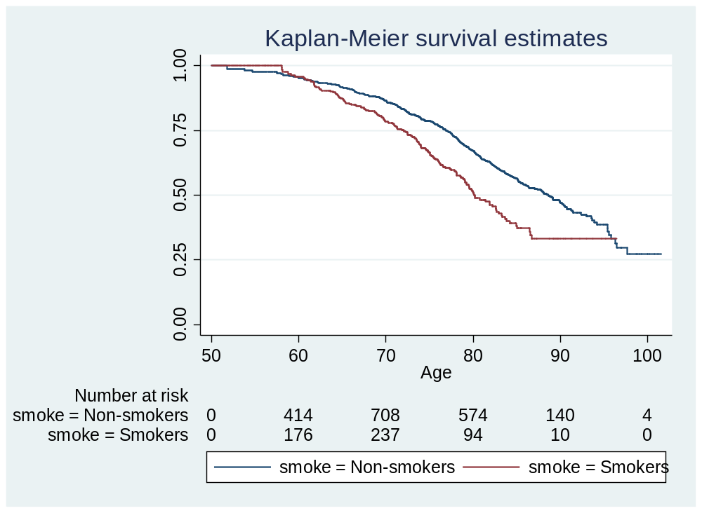
The shape of the survival-curves are quite different from the previous graph. The table at the bottom illustrates the delayed entry. Right before age 50 there are 0 in the risk set (Since the youngest is 50 years at baseline). Then the size of the risk set starts to increase followed by a decrease when the participants leaves the risk set either because they get CHD or because they are censored. In this graph we can compare smokers versus non-smokers at specified ages, for instance a 70 year old smokers versus a 70 year old non-smoker.

Exercise 3: Cox regression

- We can also get an adjusted hazard ratio for the association between smoking and risk of CHD by using Cox regression. Go back to using time from baseline as the time-scale and estimate a
Cox-regression model with adjustment for age and sex:
stset days_chd_hospdeath, failure(chd_hospdeath==1) /// scale(365.25) id(partid)
stcox i.smoke age i.sex
No. of subjects = 1,979 Number of obs = 1,979
No. of failures = 544
Time at risk = 24780.17522
LR chi2(3) = 286.59
Log likelihood = -3812.6675 Prob > chi2 = 0.0000

------------------------------------------------------------------------------
_t | Haz. Ratio Std. Err. z P>|z| [95% Conf. Interval]
-------------+----------------------------------------------------------------
smoke |
Non-smokers | 1 (base)
Smokers | 1.654291 .1638506 5.08 0.000 1.362398 2.008722
|
age | 1.076505 .0053572 14.81 0.000 1.066056 1.087056
|
sex |
Woman | 1 (base)
Man | 2.104859 .1864504 8.40 0.000 1.769387 2.503936

The hazard ratio is 1.65 and still significant after adjustment for age and sex. The HR for men versus women is 2.10, indicating that men have about twice as high risk as women, even after adjustment for age and smoking.

- After estimating the Cox-model we can test if the proportional hazards assumption is violated:
estat phtest, detail

Test of proportional-hazards assumption

Time: Time
----------------------------------------------------------------
| rho chi2 df Prob>chi2
------------+---------------------------------------------------
0b.smoke | . . 1 .
1.smoke | 0.04021 0.87 1 0.3506
age | -0.07632 2.59 1 0.1075
0b.sex | . . 1 .
1.sex | -0.02190 0.26 1 0.6116
------------+---------------------------------------------------
global test | 4.35 3 0.2256
----------------------------------------------------------------

The null-hypothesis is that there are proportional hazards. Since p>0.05 we do not reject this hypothesis and conclude that there is no violation of the assumption of proportional hazards.

- You can also get cumulative hazard curves separately for smokers and non-smokers with the stcurve-command. This is predicted cumulative hazards where age and sex are kept at the mean value in the study population:
stcurve, cumhaz at1(smoke=0) at2(smoke=1) name(cox_cumhaz, replace)
We use the name-option to store the graph in memory in Stata because we are going to resuse it later in the exercise.
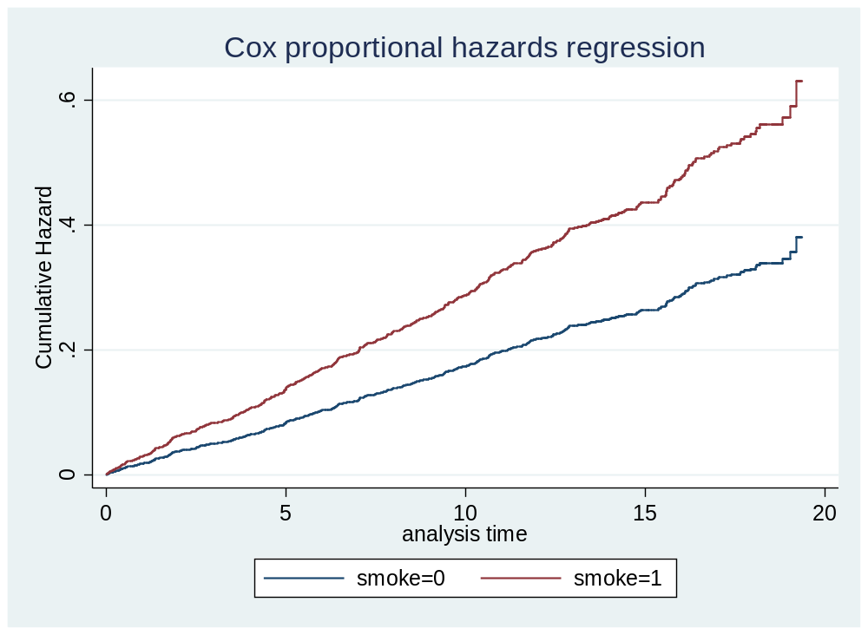

Exercise 3: Competing risk regression

Since smoking is also associated with other causes of death (COPD, cancer) there is reason to believe that death from other causes is a competing event for the association between smoking and CHD. We have treated death from other causes as censored observations, but then the HR should be interpreted as the association between smoking and CHD given that it is not possible to die from other causes. We will now investigate if competing risk affects the association between smoking and CHD.
- First we have to make a new event-variable with three values: 1 for CHD, 2 for death from other causes and 0 for censoring.
gen chd_hospdeath2=chd_hospdeath
replace chd_hospdeath2=2 if chd_hospdeath==0 & death==1 & ///
!inlist(substr(death_cause,1,3),"410","411","412","413","414") ///
& !inlist(substr(death_cause,1,3),"I20","I21","I22","I23","I24","I25")

tab chd_hospdeath chd_hospdeath2
The cross-table between the old and the new event-variable tells us that 505 of the previously 1435 censored observations has now been defined as competing events:
chd_hospde | chd_hospdeath2
ath | 0 1 2 | Total
-----------+---------------------------------+----------
0 | 930 0 505 | 1,435
1 | 0 544 0 | 544
-----------+---------------------------------+----------
Total | 930 544 505 | 1,979 b)b)

- Rerun the stset-command with the new event-variable:
stset days_chd_hospdeath, failure(chd_hospdeath2==1) ///
scale(365.25) id(partid)
We can still use the old variable for time-to-event.
- Estimate a competing risk regression model with death from other causes treated as competing event with the stcrreg-command:
stcrreg i.smoke age i.sex, compete(chd_hospdeath2==2)
Competing-risks regression No. of obs = 1,979
No. of subjects = 1,979
Failure event : chd_hosp~2 == 1 No. failed = 544
Competing event: chd_hosp~2 == 2 No. competing = 505
No. censored = 930

Wald chi2(3) = 189.66
Log pseudolikelihood = -3931.4484 Prob > chi2 = 0.0000

(Std. Err. adjusted for 1,979 clusters in partid)
------------------------------------------------------------------------------
| Robust
_t | SHR Std. Err. z P>|z| [95% Conf. Interval]
-------------+----------------------------------------------------------------
smoke |
Non-smokers | 1 (base)
Smokers | 1.425991 .1447099 3.50 0.000 1.16879 1.73979
|
age | 1.052571 .0047269 11.41 0.000 1.043347 1.061877
|
sex |
Woman | 1 (base)
Man | 1.994486 .1794466 7.67 0.000 1.672042 2.379111
------------------------------------------------------------------------------
The SHR for smokers is 1.43 while the HR from Cox-regression was 1.65. This happens because smokers are more likely to die from other causes than non-smokers. The subdistribution hazard for smokers is therefore reduced, causing the ratio between smokers and non-smokers to be closer to 1.

- After estimation of competing risk regression models we can obtain adjusted cumulative incidence curves with the stcurve-command:
stcurve, cif at1(smoke=0) at2(smoke=1) name(compete, replace)
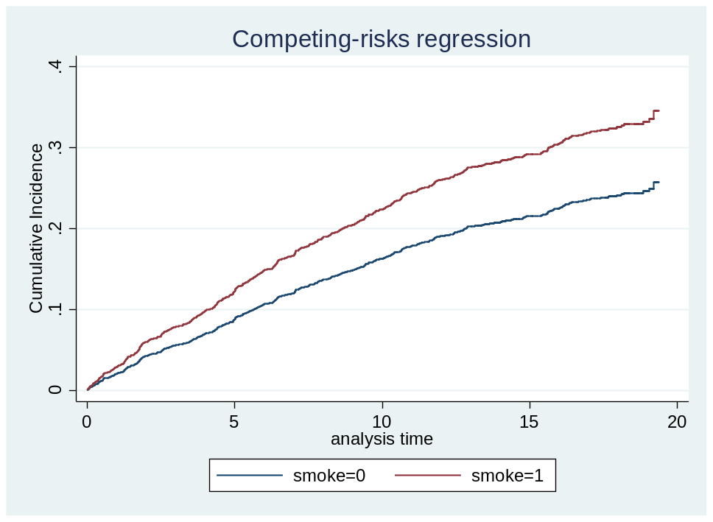
- We can also obtain estimates of the cumulative subdistribution hazard and compare this with the cumulative hazard from Cox regression by using the graph combine-command to plot the two graphs in the same graph area:
stcurve, cumhaz at1(smoke=0) at2(smoke=1) name(compete_cumhaz, replace)
graph combine cox_cumhaz compete_cumhaz, ycommon
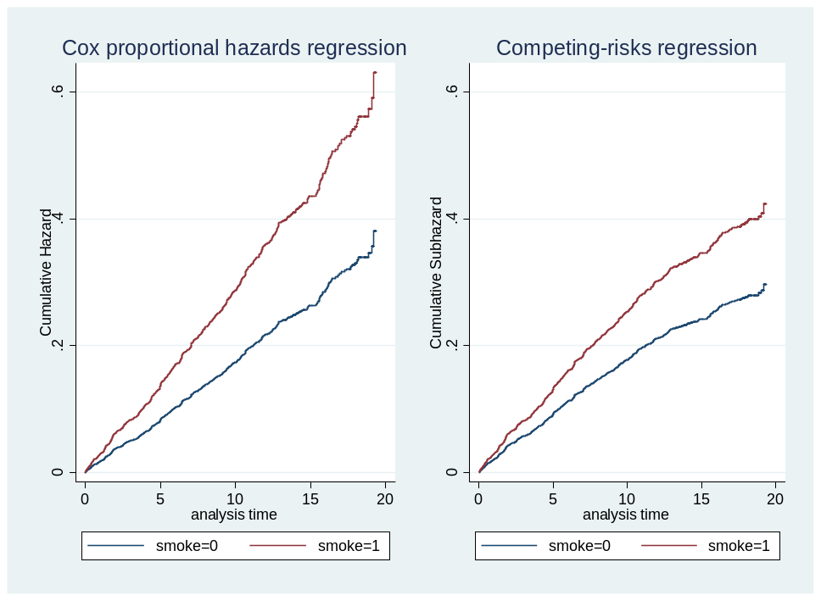

If you have time you can try to re-run the analyses with HDL-cholesterol as the main exposure instead of smoking. Is competing events affecting the association with CHD also in this case?

